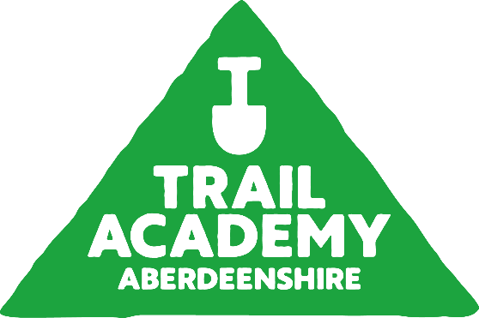
Trail Academy: Aberdeenshire - Application Form (must be returned by 26th May)

This exciting new pilot project will offer 6 young people a chance to engage in an industry led trail building academy programme.

Trail Academy: Aberdeenshire is aimed at young people aged 12-18 who mountain bike and have been, or have a desire to, build and maintain mountain bike trails.

This programme aims to increase knowledge and skills around trail building, provide insight into the process behind authorised trail building projects, highlight the importance of positive landowner and community relationships and look at how we build mountain bike trails in areas where there are protected species. Sessions will develop/include the following:

- Increased knowledge around trail building tools & techniques.
- Understanding of environmental factors which influence trail building.
- Planning trail maintenance and improvements.
- Participation in professional and volunteer trail building / maintenance sessions.
- Awareness of further trail builder training, education & career opportunities.
- Working as part of a team.
- Trail testing.

This project is led by Developing Mountain Biking in Scotland (DMBinS) and North East Adventure Tourism (NEAT) with support from Aberdeenshire Trail Association and funded via The Cairngorm Capercaillie Project. CRC Trails will provide trail building instruction on site. Where required a qualified MTB Coach/Guide will lead riding sessions. These coaches and trail builders have been selected based on their knowledge, experience and reputation within the trail building industry.

This is a pilot programme and sessions will utilise the trail network at a number of different locations across the region. We will use a mini-bus to transport students to and from Aboyne Academy. Trail Academy students will be required to ride bikes and physically contribute to trail building or maintenance sessions. Access to a bike, transport to/from Aboyne Academy or other equipment should not be a limiting factor in applying, and DMBinS will endeavour to meet the needs of all participants.

The Academy programme will start on 4th June normally running on a Tuesday Evening 4-7pm for 4 weeks (with an additional Thursday evening session on 20th June). A full detailed timetable will be sent to the successful applicants, but please ensure you can attend the following dates before applying:

Date | Location | Focus
4.06.24 | Tarland | Introduction to Trail Maintenance, Local Projects & International Opportunities
11.06.24 | Tarland | Professional Trail Design & Building
18.06.24 | Pitfichie | Trail Maintenance and construction on natural trails.
20.06.24 | Pitfichie | Summer Solstice Dig Day (Note: This is a Thursday evening and is part of a wider event)
25.06.24 | Pitfichie | Evaluating and Planning New Trails

For those selected, there will be an online pre-start online session on 30th May for parents, guidance teachers, and trail academy students to outline the programme and provide an opportunity to ask questions. There will also be a follow up session to share some of the work, learning and a short-film made during the programme.

Whilst these sessions will take place afterschool, it important that permission is granted from parents/guardians, but also education staff, especially for those who may require to leave school early to attend.

Application Form

Please save this as a copy, fill and return to fee.wallace@scottishcycling.org.uk

Whilst this is a pilot project, we hope to run this again and build on the anticipated success. Successful applicants will be contacted by Fee Wallace (DMBinS) by the 28th May. Sadly, we will not be able to offer everyone a place on this programme, but we would invite everyone to attend the Dig Days that are run via Aberdeenshire Trail Association and begin to develop skills, and experience ready for the next round. More info can be found here: www.aberdeesnhiretrail.org

Name
Date of Birth (Age)
School Year
Address
Applicant Contact Details | Phone:  Email:
I can confirm I can attend (please tick):
4.06.24 ☐
11.06.24 ☐
18.06.24 ☐
20.06.24 (Thurs) ☐
25.06.24 ☐

Consent to the action and sharing publicly of:

Be filmed ☐

Be photographed ☐

Consent
Parent/Guardian:

Name: _____________________________________________

I can confirm that I give consent for ________________________ to attend and that I will collect them from Aboyne Academy at 7pm.

Signed: _________________________________ Date: _____/_____/______

Phone: _________________________________

Email: __________________________________

Education:

I can confirm that I am aware of the above named young person applying to join the Trail Academy: Aberdeenshire, and support this application. In doing so, I have made the teaching staff aware they may need to leave sharp on the above dates to ensure attendance.

Name and role: ____________________________________________________________

Signed: ______________________________ Date: _____/_____/______

Phone: ______________________________________

Email: _______________________________________

Equipment: | This will not affect your application but is simply for planning purposes.
(Please Tick)
I have access to a working mountain bike and helmet and will bring them with me ☐

I need to borrow a mountain bike and helmet ☐

I can make my own way to Aboyne Academy for 4pm on the above dates ☐

I need support to make my way to Aboyne Academy for 4pm
( or I do not attend Aboyne Academy) ☐

Application:
Tell us about your experience with/ or desire to get into trail building. (max 150 words)

Return to fee.wallace@scottishcycling.org.uk by 26th May!!

